Assignment 3 – UI implementation

INFO20005 – User Interface Development

Revant Srivastava – 1617157 – [revants@student.unimelb.edu.au](mailto:revants@student.unimelb.edu.au)

Tutor – Le Fang

Tutorial time – Friday 12pm

[revants@student.unimelb.edu.au](mailto:revants@student.unimelb.edu.au)

GitHub repository: <https://github.com/rev2006/assignment-3.git>

Live website: <https://rev2006.github.io/assignment-3/>

# Project Overview

This step of the project was aimed at finalizing and creating the *FUNKY TRUNKS* website. It aims at fulfilling all established business goals, including increasing website engagement and total sales, as well as appealing to the target audience. The live website will feature a central homepage, product listing pages, product pages, a profile page, cart page, a checkout and confirmation page, therefore containing all primary pages of the interaction flow. The website will also be responsive and dynamic, as the UI element swill react directly to the user, and changes in screen aspect ratio will cause dynamic changes to the webpage. The website will be a recreation of the Figma prototype, being built on HTML, CSS and JavaScript and housed in GitHub. The website may incorporate some changes over the prototype which were deemed necessary to further improve user experience and enhance the usability of the website.

The primary aim of this project is to create a user-friendly and visually attractive website which also aligns with the brand identity of being bold, vibrant and unique. Overall, the project focuses on recreating the Figma prototype as a live website which meets both business and user needs.

# Structure annotation

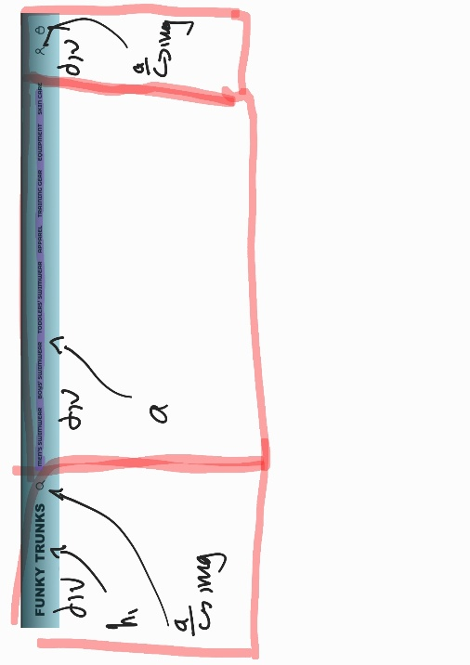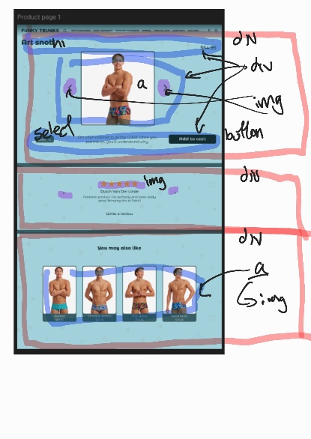

I have annotated the structurally complex pages of my Figma design to display the tags I plan on using and the structuring I will follow in my pages. As displayed, I will group large sections of content with “div” tags, which will help is separate and establishing groups of content. Within each “div”, if required, I will further employ “div” tags to group content, such as product listings, which have common fate. This will allow for each manipulation and arrangement of groups of items within their larger group. Under every “div” tag there will be the relevant content tag, such as “h1”, “h2”, “h3” for headings and sub headings, as well as “a” for links and “img” for images. Some images may also be used as links under the “a” tag. I will also use the “button” and “select” tag where necessary, as well as the “input” tag to take in user input.

# Changes and Improvements

Throughout the website, I have made some minor, and a few major changes, all of which I believe enhance the user experience. These changes range from structural changes in the website layout to the size of elements and fonts. I have documented all the major changes implemented below to present any mismatches between the actual website and the Figma prototype.

Sizes of elements and fonts have been slightly adjusted to alter hierarchy and create more visually consistent looking elements. These changes include, but are not limited to, increased font size for page title, changed dimensions of “add to cart” button and adjusting the font sizes and input fields on relevant pages. These changes were necessary to create a more professional looking website while also improving visibility of the elements and text.

I have chosen to remove the product grouping pages in my website. The use of this page was to group product listings into more specific categories, for example, men’s swimwear had multiple sub-categories, such as trunks, briefs, etc. This was also the case in boys’ and toddlers’ swimwear as well as apparel. However, upon implementation, this page is very redundant, as it provides no value to the webpage while making the interaction flow longer, hence I am deciding to remove this page and have all the sub-categories grouped together, which follows external consistency as many other clothing websites do not have this separate page. To make up for this, I have added a small label between the product name and price, naming the category which the product belongs to. I have also joined the training gear and equipment pages back into “gear & equipment”, as present in the original website, as it maintains consistency and the 2 groups are relatively similar.

The website layout of the product pages has also been noticeably altered, with it now adopting a left-to-right layout rather than a top-down layout. This is as the original top-down layout on desktop left a large amount of white space surrounding the square image in the centre. The image could not be further increased in size as it would not fit the viewport and couldn’t be decreased in size since that would make it too small. At the current size, only half of the relevant content was visible, making it hard for the user to take in all the information provided without having to scroll. Therefore, I opted to change the layout by putting the item name and price to the left of the image and the description, size and add to cart button the right, allowing for all the content to fit onto the screen together while still being spaced out and uncramped. This change increased the visuals of the website as there was now less whitespace, and also increased ease of use as more content was visible.

The addition of the scroll bar was a necessary improvement which had to be made on the website. The prototype lacked a scroll bar underneath and side scrolling content, which may make it harder to identify scrollable content and could also make scrolling difficult on mouse and keyboard. Therefor I adopted a simple scroll bar, which follows the color theme and appears a reasonable distance beneath the related section, allowing users to scroll straight from it.

The review section under the product page has been slightly altered from the prototype. In the prototype, the content size relative to the space it occupied was small, leaving a lot of empty space surrounding the content. The width of the reviews has been increased so it takes more space vertically. Furthermore, the size of elements, such as the stars has been slightly increased to establish a clearer hierarchy, and the left and right button have been noticeable enlarged to improve usability, especially for users on devices with smaller screens.

Additionally, on the cart page, I added an “X” button to the right of every product row to easily remove any products from the cart. This was a minor UI element which was overlooked in the previous design stage; hence I added it to improve usability of the website. The addition of the “X” button meant I had to slightly shift all other elements in the cart row slightly to the left, creating some mismatch between the Figma prototype and final design, however, it was necessary for this change to take place as it greatly increases UX on the cart page.

Throughout all the pages, the main h1 title size has been increased to very clearly establish it at the top of the hierarchy. This is a minor change as the size has not been drastically increased, however, it is noticeably larger and very beneficial to the UX of the website, as it enhances clarity.

The website now includes interactive animations that enhance user engagement. All clickable images feature smooth hover effects where both the image and its container slightly increase in size and darken, providing immediate visual feedback. This design choice not only adds dynamic and a modern feel to the interface but also clearly indicates interactivity, making it easy for users to identify clickable elements. As a result, the overall usability and intuitiveness of the website are significantly improved.

# Critical Reflection

Overall, the project was a success, with most goals met and only a few minor setbacks encountered along the way. The primary achievement was the development of a fully functional and visually engaging website for FUNKY TRUNKS, aligned with the initial design requirements. The final product maintains a distinctive, “funky” aesthetic while ensuring that the site remains user-friendly and easy to navigate.

One of the key successes was the faithful implementation of the Figma prototype. Using HTML and CSS, I was able to closely replicate the layout and visual design and then enhance it with JavaScript to achieve the desired interactivity and functionality. This resulted in a cohesive and operational website that matched the design intent presented in the earlier stages of the project.

One of the key successes was the faithful implementation of the Figma prototype. Using HTML and CSS, I was able to closely replicate the layout and visual design and then enhance it with JavaScript to achieve the desired interactivity and functionality. This resulted in a cohesive and operational website that matched the design intent presented in the earlier stages of the project.

Challenges were primarily technical, especially with CSS and JavaScript. As the project evolved, new UI components were introduced, which required frequent revisiting and refactoring of existing code. This occasionally led to duplicated CSS rules and inconsistencies between HTML and CSS, which needed to be fixed to ensure code integrity. Additionally, implementing some dynamic features using JavaScript proved complex. For example, enabling functionality such as saving product data to local storage and dynamically displaying that data, which included images, names, prices, and quantities, in the shopping cart required careful logic and troubleshooting. Alongside this, there was also the constant challenge of adjusting the design to fit the mobile interface to keep it aligned with the prototype. This involved much trial and error as the already existing UI elements had to be re-adjusted for the new aspect ratio, as well as certain behaviours including the appearance and disappearance of elements based on aspect ratio. These challenges, however, were ultimately overcome, and did not hinder the final delivery of the project. The iterative development process, where previous work was regularly reviewed and improved, played a major role in ensuring overall success.

There are, however, areas identified for future improvement. Features like a fully operational "sort by" and "search" functionality were not implemented, as they fell outside the initial scope of the brief. In addition, some secondary pages, such as the profile page and its linked child pages, remain basic in design. Enhancing these pages with richer content and imagery would improve the overall depth and professionalism of the site. Similarly, expanding the content and design of connected pages could further enrich the user experience. Additionally, pages such as the home page could also have more content displayed on them, creating a longer page with more links and visuals.

In conclusion, the project has largely met its design objectives, delivering a functional, visually appealing, and user-friendly website. The experience has highlighted the importance of flexibility in design implementation, as well as the value of iterative improvement. With additional time and scope, further refinements could be made to elevate the project even further. Based on this, I believe that the I have achieved the design goals set and created a website fit for the business and user requirements.

# List of Code Files

HTML files

index.html (homepage/ index page). Artsnob.html, Bolted.html (product pages). apparel.html, boys_swimwear.html, gear_and_equipment.html, mens_swimwear.html, skincare.html, toddlers_swimwear.html (products listing pages). Cart_page.html (shopping cart page). checkout_page.html (checkout/payment page). create_account.html (account creation page). Forgot_password.html (forgot password page). profile_page.html (profile page).

CSS files

* A3.css (the primary CSS file concerning all the sizes, layouts and positioning and some of the behaviour UI elements seen across all pages)
* A3_fonts.css (contains the imported typeface used and applied to all the text throughout the website, as well as all the CSS relating to changing and adjusting the fonts)
* A3_colors.css (CSS file dealing with the colors of all UI elements throughout the website)

JavaScript files

* A3.js (the single JS file containing code relating to the behaviour of the website, with its main uses being hiding and showing elements based on screen aspect ratio and adding products to cart)